**AWS S3 EVENT TRIGGERING**

AWS S3 Event triggering is a very popular project used by top companies in the Industry.

Here are some examples of top companies that use S3 event triggering:

**Netflix**: Netflix use S3 event triggering to automatically process video files uploaded to Amazon S3, enabling seamless content ingestion and processing.

**Airbnb**: This lodging and homestays aggregator use S3 event triggering to automatically process and analyze data stored in Amazon S3, such as guest reviews and booking information.

**Expedia**: They use S3 event triggering to automatically process and analyze data stored in Amazon S3, such as travel bookings, user profiles, and pricing information, to power their personalized travel recommendations and search features.

Setup the Infrastructure to make this possible follow the steps:

1. Create a Lambda Function and name it as everyone should understand

And create IAM Role for the Lambda and Give Permissons of Lambda Access,

S3 Access,SNS Access.

Why S3 access is to get the event notifications when any object is uploaded to

S3 Bucket

Why SNS Access is to send notifications to user who are subscribed to get notifications when new file is uploaded.

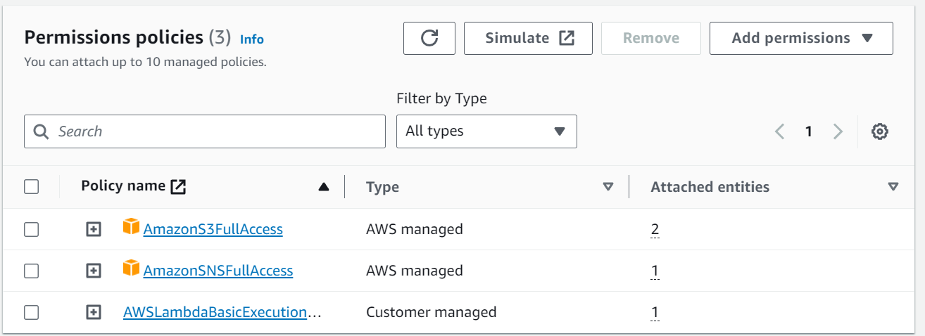

1. Create S3 Bucket with Proper Name and Permissions after that Go to Properties of S3 Bucket and Scroll Down to Event Notifications

Add target as Lambda Function which created before and get Notification when any object create/upoad/put access

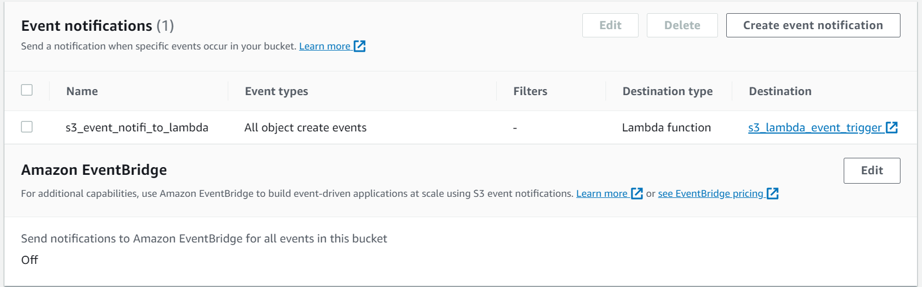

1. Creating SNS Topic and add a subscription in that details provide your type of receving Notification add email to and save

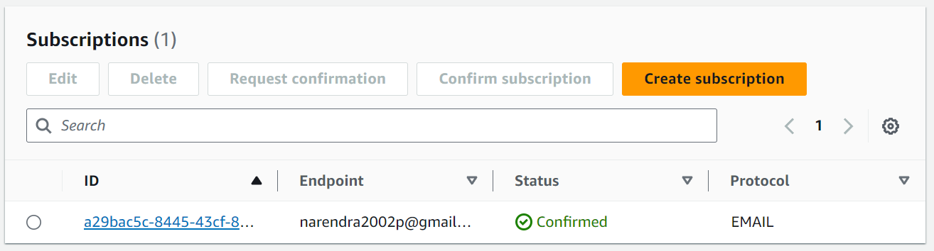

1. Coming to Lambda Function write code in to send Notification to SNS it will send to mail.

Lambda Function get event message when we push any Object to the S3 Bucket Storage.

Because of Object Create Event is Occurred in the S3 Lambda is triggered and

Notification Went

**Code for Lambda Function:**

import boto3

def lambda_handler(event, context):

object_name=event['Records'][0]['s3']['bucket']['name']

object_key=event['Records'][0]['s3']['object']['key']

sns_client=boto3.client('sns')

response = sns_client.publish(

TopicArn='arn:aws:sns:ap-northeast-1:280891701417:s3_lambda',

Subject='s3 object creation',

Message=f'{object_key} file is pushed to the s3 bucket {object_name}'

)

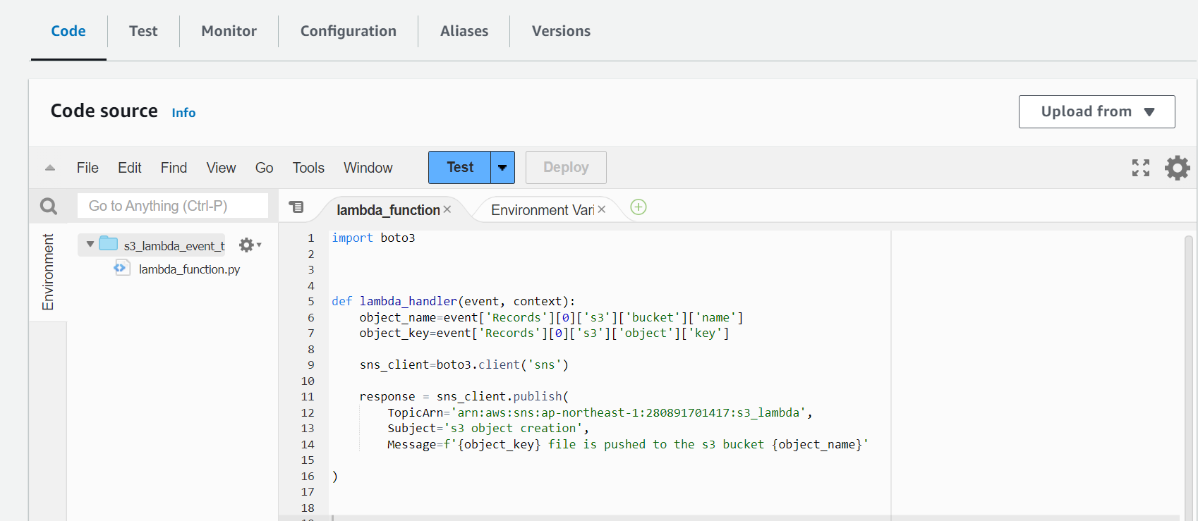

1. Finally Testing the Infrastructure we set up in the AWS

Upload a file or anything into S3 Bucket and check any Notification you received or not through type of receveing you created in SNS Topic.

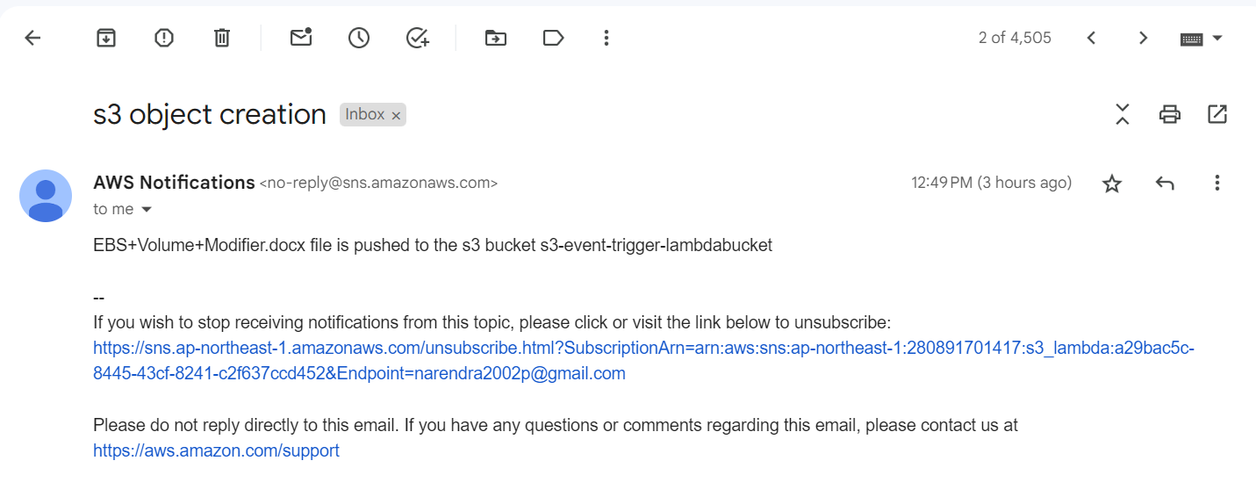

**Note:**

1. If any Error Occurred try Debug by checking cloud watch logs